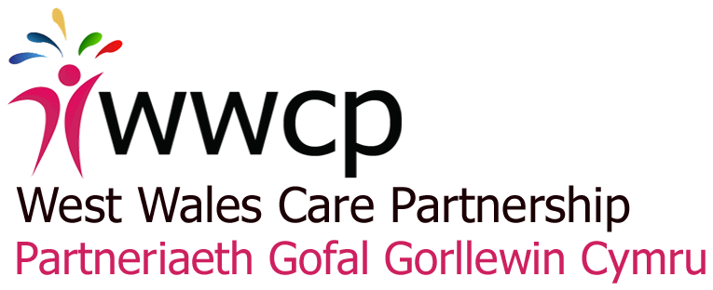
Appendix 2

West Wales Care Partnership

Integrated Care Fund 2017-18

Written Agreement

May 2017

Partners

Carmarthenshire County Council
Ceredigion County Council
Hywel Dda University Health Board (HDUHB) Pembrokeshire County Council
Pembrokeshire County Council

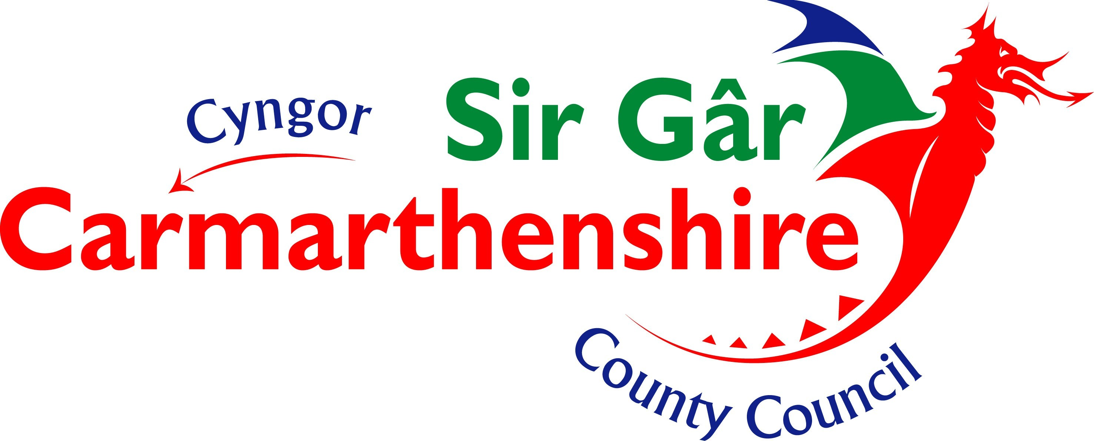

Signatories

Steve Moore, Chief Executive of Hywel Dda University Health Board

Karen Miles, Director of Finance, Planning and Performance, Hywel Dda University Health Board

Jake Morgan, Director of Communities, Carmarthenshire County Council

Sue Darnbrook, Strategic Director – Care, Protection and Lifestyle, Ceredigion County Council

Jonathan Griffiths, Director of Social Services and Leisure, Pembrokeshire County Council

- Background

The Integrated Care Fund (ICF) is provided by Welsh Government as ‘an effective delivery mechanism for the Social Services and Wellbeing Act’. Its conditions reflect priority areas for integration identified for Regional Partnership Boards (RPBs) under Part 9 of the Act, namely:

- Older people with complex needs and long term conditions, including dementia
- People with learning disabilities
- Children with complex needs due to illness or disability
- Carers

The ICF comprises Capital and revenue streams and totals £60 million across Wales. Funding is paid to Local Health Boards (LHBs) for deployment across their footprint areas.

For West Wales the 2017-18 allocation has been confirmed as follows:

Revenue

 | £M
Older people | 4.140
Learning disabilities/ complex needs | 1.845
Integrated autism service | 0.298
WCCIS | 0.184
Total | 6.467

Capital (grant – to be confirmed)

£M
Total 1.301

RPBs established on LHB footprints have a responsibility to ensure effective deployment of ICF funding in their area.

- Status of this agreement

This agreement has no binding legal effect although partners undertake to meet the obligations listed within it. Separate partnership arrangements may be entered into by 2 or more partners to commission and/ or deliver services funded through the ICF.

- General principles

Partners agree to work to the following principles in delivering projects funded through the ICF:

- All Partners will work in partnership in order to achieve the aims set by Welsh Government in relation to the ICF and to work to the mutual benefit of all partners in delivering funded programmes.

- Partners will share all relevant information and intelligence including any sensitive messages emerging which might impact on delivery.

- Partners will provide each other with as full and open as possible access to policy information including statistics and research and where appropriate representation from third parties.

- Partners will observe confidentiality in relation to shared information which is not in the public domain.

- Partners commit to engaging, involving and working in partnership with stakeholders, service users, carers and the wider public to ensure that agreed milestones and outcomes are achieved.

4. Specific roles and responsibilities

Regional Coordination

The Regional Collaboration Unit (RCU), hosted by Carmarthenshire County Council, will provide overall programme coordination on behalf of the RPB. Specifically, this will involve:

- Following consultation with RPB members, advising partners on the regional allocation, including:
- The total value of the award
- Amounts allocated by Welsh Government to support specific initiatives (e.g. implementation of WCCIS, Integrated Autism Service)
- Top sliced amounts to support (1) regional coordination, (2) delivery of RPB strategic priorities and (3) other region-wide projects that contribute to the Area Plan
- Net amounts available for local projects which will be agreed through local governance.

- Providing partners with comprehensive guidance on deployment of the ICF, standards for local governance and standard templates to be completed for each funded project to assist programme coordination.

- Compiling a regional programme comprising all programmes (local and regional) funded through the ICF, for consideration by the Integrated Programme Delivery Board (IPDB) and agreement by the RPB.

- Advising the RPB on the fit of the programme and its constituent projects with the aims of the ICF as stated by Welsh Government.

- Making recommendations to the RPB regarding bids for the regional projects fund.

- Submitting the agreed programme to Welsh Government.

- Eliciting the approval of Capital schemes by Welsh Government prior to commencement.

- Coordinating the regional implementation and reporting of WCCIS

- Ensuring reporting requirements are met in relation to the Integrated Autism service.

- Aggregating performance and financial information submitted by partners, including achieved outcomes, into quarterly reports for consideration by the IPDB and signing-off by the RPB prior to submission to Welsh Government.

- Establishing and maintaining a regional risk register.

- Financial monitoring, which will involve:
- Collating annual financial profiles submitted by all project leads
- Monthly collation of legitimately-incurred expenditure by partners over the past month and submission of invoices from the local authority partners to HDUHB for reimbursement
- Producing monthly expenditure reports and aggregating these on a quarterly basis for inclusion in quarterly progress reports.

- Developing mechanisms to facilitate the sharing of learning and effective practice emanating from funded projects.

- Facilitating regular meetings of nominated ICF leads to share learning and outcomes, contribute to performance management and evaluation and develop proposals for future regional projects.

- Representing the region in national discussions with Welsh Government and others in relation to the ICF.

Hywel Dda University Health Board (HDUHB) will hold the funds issued by Welsh Government for the ICF and will administer the fund on behalf of the West Wales Care Partnership. This will involve:
- Paying monthly, validated invoices submitted by local authority partners for reimbursement of their incurred costs and those of third sector partners in delivering the programme.
- Effecting internal transfers to meet validated incurred costs by the Health Board in delivering the programme.
Project initiation, management and reporting
Local Authority and Health Board partners will be jointly responsible for the development and management of projects in partnership with other stakeholders as appropriate, to be delivered with the available funding. This will involve:
- Submitting proposals for regional projects that contribute to the Area Plan to the RCU for consideration by the RPB.
- Jointly agreeing projects to be funded through identified local governance.
- Providing the RCU with terms of reference of local forums at which funding decisions are taken.
- Submitting minutes of meetings of the above forums recording funding decisions.
- Completing Project Brief and Reporting Templates provided by the RCU.
- Evidencing that projects meet the criteria of the Fund.
- For each project, providing information on local project management arrangements, budgets and spend profiles, aims, objectives and key outcomes, milestones, additional funding and plans for project sustainability.
- Identifying a Lead Officer for each LA area who will be the principal point of contact with the RCU for purposes of reporting, accountability and practice sharing etc.
- Managing risks associated with each project, maintaining an up to date risk register.
- Managing staff and other resources and putting appropriate transitional/ succession arrangements in place to support projects beyond the funding period as appropriate.
- Monitoring delivery of activity and associated expenditure and mitigating identified risks to ensure timely delivery of identified objectives and outcomes.
- Submitting monthly statements of legitimately-incurred expenditure for the previous month with appropriate backing evidence to the RCU for validation (Local authorities to provide information in relation to their expenditure and that of non-Health Board partners; Hywel Dda University Health Board to provide information in relation to its expenditure).
- Submitting monthly invoices, approved by Directors of Finance (DOF) and reflecting legitimately-incurred expenditure for the previous month, to the RCU for forwarding to HDUHB. DOF will need to ensure that the invoices submitted are in line with the terms of the grant and are supported by backing documentation that will satisfy the needs of internal and external auditors.
- Ensuring that their organisations and/ or other partners do not spend more than the projects funds available to them through the ICF. Any such overspends will need to be met by the partner that has incurred the overspend.
- Managing potential overspends, underspends and slippage, obtaining formal approval through recognised local and regional governance, proposed reallocation of underspend to eligible projects and submitting these for endorsement by the RPB within timescales indicated on Page 8 below.
- Producing quarterly activity updates within agreed timescales using the Reporting Templates provided by the RCU and providing reasons for variance from stated objectives and profiled expenditure, and submitting these to the RCU for incorporation in overall programme reports.
- Collecting and collating activity and financial information from other partners involved in delivering projects to inform the updates.
- Sharing and exchanging information on matters of mutual interest in a timely and helpful manner.
- Committing to provide relevant policy and statistical information and research data in relation to funded projects.
- Participating in sessions facilitated by the RCU to share learning and outcomes, contribute to performance management and evaluation and develop proposals for future funding through the ICF.
- Adhering to all the WG funding Terms and Conditions. A copy of full terms and Conditions are included in the national ICF Guidance and attached to this Agreement (Appendix 1).

- Agreeing to bear their own costs in relation to any ineligible expenditure incurred and identified either prior to a claim or subsequent to any claim however identified.

- Agreeing to reimburse HDUHB any funds that have been used for ineligible expenditure within a reasonable time period.
5. Timescales for submission of financial information and reporting on progress
A schedule for the monthly submission of invoices and financial information for payment is provided below.
Insert
A schedule for progress reporting is provided below.
Submission of reports to RCU | Consideration by IPDB | Sign-off by RPB | Submission to Welsh Government
Programme sign-off
10 May 2017 (information on proposed footprint-wide projects and locally agreed projects | Virtual | 19 May 2017 | 26 May 2017
Quarter 1 reporting
21 June 2017 (interim Q1 reports) | 30 June 2017 (interim Q1 report) | N/A | N/A
19 July 2017 (final Q1 reports) | Virtual (final Q1 report) | 26 July 2017  (final Q1 report) | 29 July 2017
Quarter 2 reporting
13 Sep 2017  (interim Q1 reports) | 22 Sep 2017  (interim Q1 report) | N/A | N/A
18 Oct 2017 (final Q1 reports) | Virtual (interim Q1 report) | 27 Oct 2017 (final Q2 report) | 3 Nov 2017
Quarter 3 reporting
15 Nov 2017 (interim update and slippage proposals) | 24 Nov 2017 (interim update and slippage proposals) | 8 Dec 2017 (interim update and slippage proposals) | N/A
17 Jan 2018 (final Q3 reports) | 26 Jan 2018 (final Q3 report) | Virtual | 31 Jan 2018
Quarter 4 reporting
7 Feb 2017 (interim Q4 reports) | Virtual | 16 Feb 2018 (interim Q4 report | N/A
Final Q 4 reporting schedule to be agreed

Appendix 1 – to follow

