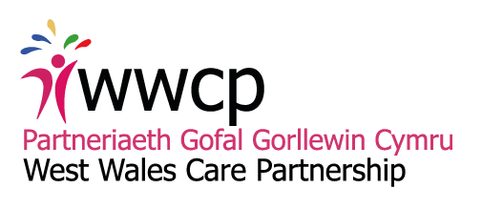
Item 9 (1)

Exception Report: Transforming Learning Disabilities
Period covered by the Report | Up to 17th October, 2017
Summary of overall status | The Learning Disabilities Programme Group are working towards achieving objectives outlined in the LD Service Redesign project initiation document. See also key milestones below
Key Risks | Below are the most significant and/or most relevant risks taken from the Risk Register.  Risk Statement Existing Control Measures Currently in Place  There is a risk that organisational budgets will be reduced. This is caused by financial pressures within organisations. The impact is project overspend and inability to deliver revised service model with available resources. HDHB Commissioning team are undertaking a review local CHC commissioning practice and expenditure against national practice and programme budgeting.  There is a risk of individual care packages being subject to uplift in cost. This is caused by providers reviewing their costs. The impact is destabilisation of individual placements along with increased cost to these organisations funding packages of care at short notice, thus increasing overspend Ensure Care Co ordinators/ case managers in LD are reviewing placements on a regular basis.  The is a risk of delay in finding suitable placements this is caused by a lack of availability of placements within the Hywel Dda area for complex needs including challenging behaviour. The impact is delays in finding placements or having to utilise costly out of area placements. Market Position Statement commissioned January 17 will inform future demand for services and identify gaps in capacity to predicated need and model of care.  There is a risk that key elements of the project will not be delivered. This is caused by the political calendar as well as operational and service pressures. The impact is people who are receiving care in settings and with staff who are not the most appropriate to meet their needs. A realistic timeline will be developed for the project to be regularly reviewed and updated. Monthly meetings to keep programme on track. Close working with local authority partners and multi agency partners to ensure robust level of engagement  There is a risk of the four agencies not aligning priorities due to the individual organisational need and funding priorities. This is caused by competing priorities within organisational structures. The impact is delays in the project progressing. Monthly meetings to review progress and milestones.
Key Issues | No new or major issues identified in this period.
Key Milestones | Milestone Target Date Comment  Establish Project Lead and Project Team June, 2016 Completed  The completion and agreement around key project papers. October, 2016 Completed  Market Position Statement & analysis of population needs assessment: Benchmarking LD service data - benchmark number of providers and beds against national picture Review local CHC / commissioning practice and expenditure June, 2017 In progress  July, 2017 and annual thereafter  August, 2017  Review the current Learning Disability model of service delivery September, 2017  Engagement with Staff Stakeholders January, 2018 & ongoing Workshop planned 19th October  Development of Options Paper/Papers for Consultation February, 2018  Consultation with Staff/Stakeholders September, 2018  Implementation of proposed future service model
Milestones achieved/Outputs (deliverables) completed in last period | Feeding into MPS data  Session with WG on LD transformation priorities  Delivery of LD related ICF projects  Monitoring of LD related ICF projects
Shortfalls/Non-completions in last period | The LDPG had planned a July date for an engagement event/workshop however this has been postponed to October 19th 2017 in order to be able to present finalised MPS data and maximise provider representation.
Forecast for next period | - Market Position Statement: Learning Disabilities Services – Provider Workshop 19th October AM - To engage further with providers on the findings of the Market Position Statement (MPS), to ensure we have a common understanding of the issues and identify how the relationship between commissioners and providers might be improved in the future  - Learning Disabilities Programme Group Workshop – Setting the Direction 19th October PM -Setting the direction and agreeing key work streams and priorities
Financial status

